ENGR 115 Final Report: Modifying the e-NABLE Hand to have Improved Grip.
Reese Mathers , Aarav Ahuja, Khoi Ton, Kendall Zabel

Executive Summary: Improving Grip on Prosthetic Hand
This project addresses the limited grip capability of the e-NABLE hand. We explored various ways that grip has been improved in prosthetics, and through our research we decided we would modify the e-NABLE hand. Using OnShape, we designed an improved e-NABLE hand that would allow us to change the grip abilities. After modifications were complete, we 3D printed the hand and made our necessary adjustments including using an EVA polymer to increase the grip. After the modifications were complete, we tested our prototype to estimate its grip strength.

Identify Need: Lack of grip strength/capability on e-NABLE prosthetic hand.
Before narrowing down on one specific need, we looked into varying needs in the prosthetics field. One need we looked into was using a BOA ratchet system to tighten the socket that attaches to the individual's residual limb [1]. We originally looked into this because we were interested in how we could design an adjustable socket to attach to the residual limb, but ultimately abandoned the need because we were more passionate about our final focus.
Alongside exploring the BOA ratchet system, we also looked into creating a cosmetic glove to go over a prosthetic hand, in order to improve the appearance of mobile prosthetic hands. Many prosthetic hands that appear human-like, do not have any functionality [2]. So we were looking into designing a silicone glove to go over a functioning prosthetic hand. This idea was also abandoned because it had a lack of engineering opportunities, as we would be merely designing a cosmetic glove.
Furthermore, we thought of some ideas about modifying a prosthetic to enhance athleticism, such as creating special attachments for certain sports and activities. While this offers more engineering challenges than the functional cosmetic prosthetic, we also realized that this would not benefit the targeted audience, people who are looking for a daily tool that would limit the user based on their activities.
Finally, we decided that we would improve the grip on the e-NABLE hand. Currently, the e-NABLE hand is printed fully with PLA filament, which is very slippery and unable to grip nearly anything. Due to this clearly problematic lac, we decided we would engineer a way to improve the grip on the e-NABLE hand. We settled on this idea because it is something we were all interested in, and something that had strong engineering potential. Before fully settling on the e-NABLE hand, we looked into other 3D printed prosthetics. We came across the Kinetic Hand [3], which is open source, 3D printable, and uses TPU hinges instead of mechanical pins to help move the hand, so we ultimately had to scrap that idea as we weren’t able to print with TPU filament with the 3D printers available to us. Ultimately, we decided on the e-NABLE hand. It is an open source 3D printed hand with freely available CAD files which made it easy for us to modify for better grip. It was most feasible to make with the resources we had available to us, making it ideal for our project. Instead of designing an entirely new hand, we focused on a specific weakness, which was its overwhelming lack of grip strength. With our base hand, it was extremely difficult to pick up any slightly slippery object, and this was due to the fact that we used PLA filament, which is quite slippery and has a low coefficient of friction.
We researched multiple possible materials to improve grip, like rubber, silicon, and EVA. When choosing which material to go with we referred back to our design criteria- and chose EVA as it is most cost effective, more durable (bonds to PLA better) and was easiest to apply. Another reason we chose EVA is because we realized that would make the replication of this design much easier for amputees hoping to print and modify their prosthetic at home- if we had made it to a feedback & distribution stage in our project this would’ve made distribution much easier.
Our research showed that EVA has a coefficient of friction of about 1.2 [4], and PLA has a coefficient of friction of about 0.5 [5], which makes EVA a significantly better option to use than PLA. EVA is also highly accessible and cheap, as it is the main polymer that is found in hot glue sticks, which made it perfect for our project.

Exploration:
The main goal was to improve grip function, since the original fingertips were rigid PLA, which is slippery and not as human-like when grabbing objects. We originally considered silicone or rubber finger covers. We did not continue with this choice because the process would require specialized materials: molds, curing agents, etc., which would increase the cost. Also, the silicone is not as durable as other options, so when it breaks/wears down, it's more expensive to replace.
We looked into textured or patterned surfaces as well. The e-NABLE hand already had textured fingerprints modeled into its design, but after printing out this control hand, we deemed that there was still little to no friction with the textured surface. This is why we resorted to a malleable material that can give us a higher coefficient of friction.
We also considered replaceable finger attachments. We proposed various different grip types that could snap onto the fingers, smooth, textured, hooks, etc. Since this is a very good idea, it is also very popular. Which is why there are already so many finger attachment designs out there, and we preferred to try something new and unique.

Design: Create divots in the e-NABLE hand in order to add grip.

Design Criteria:

Design Ideas | Cost  (2) | Grip strength  (3) | Ability to hold round/awkwardly shaped objects  (4) | Total:
Adding fingerprints to tips. | 1  1*2=2 | 1  1*3=3 | 1  1*4=4 | 9
Grip on fingertips and palm | 2  2*2=4 | 2  2*3=6 | 2  2*4=8 | 18

Cost: Cost includes creating a hand with improved grip under $50. We want this hand to be cost effective, while also being reasonable for the product that it is (a prosthetic hand).

Grip Strength: For measuring grip strength, we would measure the prototype’s ability to hold onto objects of increasing weight. Before making any prototypes, we measured this by gauging the amount of grip and how that would affect the prosthetic’s ability to hold heavy objects.

Ability to hold round/awkwardly shaped objects: For this category, much the same as grip strength, instead with objects. After creating the prototype, we would measure this by having an assortment of awkward and round objects for the prosthetic to hold. Before printing, we again related the amount of added grip to the ability to hold objects.

From our design criteria, our chosen design was adding grip on fingertips and palm. After using our design criteria to make this decision, we started working on the idea generation aspect. Brainstorming ways to add grip to a prosthetic hand.
We also considered other factors in our design process like feasibility and production time- but did not include it in our design criteria graph because they would not apply if this was a real product we were producing outside of class/school.

Idea Generation:
- A modified hand with added grip on the fingertips, which will allow the individual to grip smaller objects, and help their ability to use fine motor skills. It is also cost effective. But, it would not help the individual to grip round or awkwardly shaped objects very well.

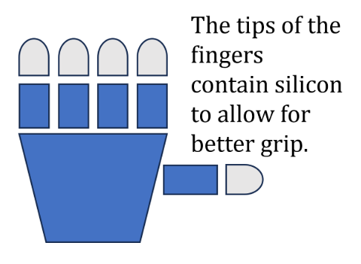
Our brainstormed design on how to modify the grip.

- A modified hand with added grip on both the fingertips and the palm. This would be slightly more expensive than only on the fingertips, but it would help the individual with fine motor skills and their ability to hold round/awkwardly shaped objects.
- Somehow modifying the hand to have more filament in places that would improve grip capabilities. This idea was the least fleshed out, as we realized it was the least practical and would not overall help the grip at all.

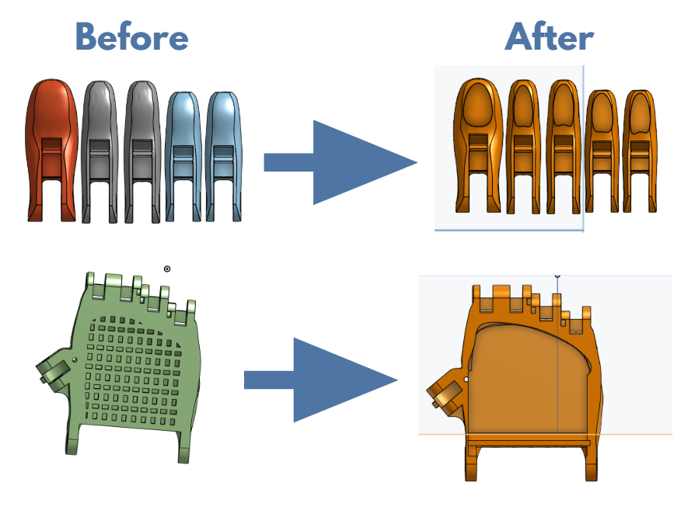

3D Design Process:
For our modifications to the e-NABLE hand, we used OnShape, which allowed us to use features such as: spline, extrude, and remove, in order to change the design in a way that would allow us to add the EVA polymer. With OnShape we created divots in the fingertips and palms, which after being printed, would allow us to add the extra grip onto the e-NABLE hand.

In the before, the hand had no divot in the palm, and the fingertips were full with PLA. In the after, a visible divot in the palm and divots in the fingertips have been created in order to add the EVA polymer after printing.

Prototype:

Materials List:
- PLA Filament (cost n/a, provided)
- EVA petroleum based polymer (cost estimated $0.50)
- Heat gun (cost n/a, provided)
- 3D printer (cost n/a, provided)

We printed 2 hands; one modified and one unmodified in order to compare the functionality of our adaptations with the original eNABLE hand. We noticed that the changes we made had a huge impact- the original eNABLE hand was unable to hold nearly anything without it slipping away. Our modified hand had no problem holding items like pens, water bottles, or phones.
Our modifications were creating divots on the fingertips and palm, and after printing, we used a heat gun to apply melted polymer within the designated hole, we allowed it to set with an uneven texture and instead of sanding it away we left it as is to mimic the texture and shape of a human hand and skin. This skin-like surface increases friction and is softer than PLA so it is able to “squish” and have a higher area of contact.

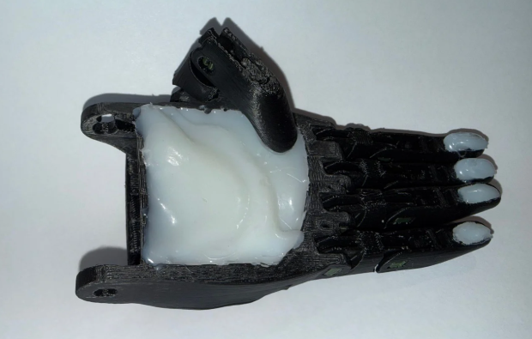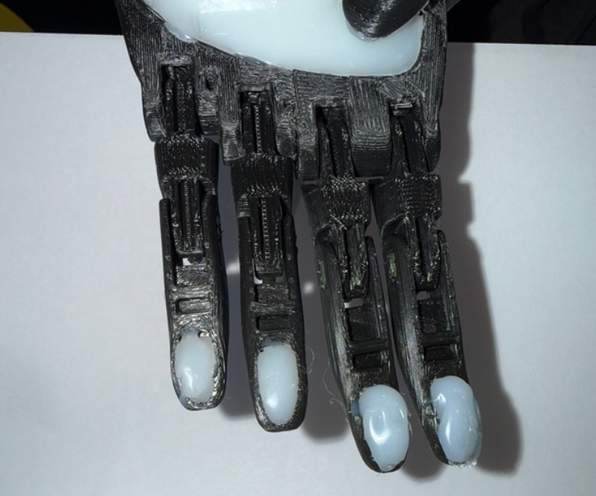
Our final prototype with modified fingertips and palm filled with EVA polymer to improve grip
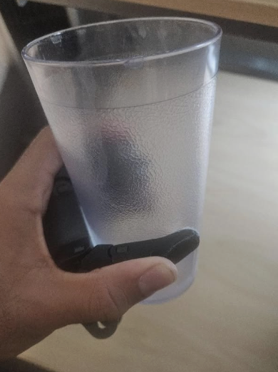
Our final prototype handing holding a round/awkward shaped object (fulfilling design criteria)

Implement:
Our theoretical future implementation process
- Survey possible users for feedback on the product.
- Test grip strength capacity with various experiments or machinery.
- Find a cost similar alternative to EVA polymer for the grip.
- Work with engineers of different fields for inputs on how to improve the design and make it more functional
For our first prototype we wanted to use a small testing group, which feels manageable for our project. We decided as a group that we would seek to find 5-10 people with varying limb differences, this is a reasonable size for a prototype. We would ask people with different arm sizes, ages, and lifestyles to test the grip strength. We want a wide variety of test users since we would be testing with a small group. This means that we would look for as much diversity amongst users as we could. We would connect with these users through local clinics, surveys, and clubs. We could find users who are willing to participate in testing out our prototype. We would ask the users to conduct various tests/tasks like picking up heavy weights, having them evaluate how easily they can grip/catch, and lastly we’d ask for their general first impressions. We would ask them to rate the difficulty of daily tasks out of 10, in order to evaluate how our prototype works.
Evaluate:
The modified e-NABLe hand showed a very clear improvement compared to the unmodified version. The original hand uses rigid PLA plastics, which is quite durable for structural components, it is lacking when gripping surfaces. Because PLA has a high Shore hardness, it creates a “tangential” contact point with the object. This can also be described as a sphere/circle on a flat surface, where contact surface is very negligible, meaning there's less friction, especially on the fingertips where it has a small and hard point of contact.
To evaluate performance, we held tests with both modified and unmodified hands by experimenting whether or not the hands would pass our “Lift and Hold” test, where they have to grip onto and hold the water bottle firmly and lift it into the air, without any slippage . We had a group of around 10 users who have tried both hands. We let numerous users do this experiment to ensure that skill was not the determining factor, rather the modifications to the hand were contributing more to the success.

What we found were:
- We observed that the unmodified hand had a 20% success rate, meaning it was consistently unable to hold the bottle properly, as the lack of friction caused the water bottle to slip out of the hand even before firmly held and lifted.

- In contrast, the modified hand that has polymer-filled divots reported a 100% success rate, due to increased coefficient of friction and larger contact area performed significantly higher than the unmodified hand, in terms of reliability, strength, and overall functionality.

We can conclude that our modification improves the grip performance and functionality of the 3D printed e-NABLE prosthetic hand. By increasing friction and contact area at the fingertips and palm, we were able to successfully hold objects that the original design could not reliably hold.

References

[1] “Bracing & Prosthetics | BOA®,” www.boafit.com. https://www.boafit.com/en-us/bracing
[2] Horton's Orthotics & Prosthetics, “How Prosthetic Hands Function,” Horton’s Orthotics &
Prosthetics, Apr. 22, 2025.
https://www.hortonsoandp.com/how-prosthetic-hands-function/
[3] Minas Liarokapis, “OpenBionics prosthetic hands: Open source, affordable, lightweight,
anthropomorphic - Robohub,” Robohub, 2015.
https://robohub.org/openbionics-prosthetic-hands-open-source-affordable-lightweight-ant
hropomorphic/
[4] Maria Giulia Faga et al., “Ethylene-Vinyl Acetate (EVA) Containing Waste Hemp-Derived
Biochar Fibers: Mechanical, Electrical, Thermal and Tribological Behavior,” Polymers, vol. 14, no. 19, pp. 4171–4171, Oct. 2022, doi: https://doi.org/10.3390/polym14194171.
[5] S. Wang, Q. Shen, C. Guo, and H. Guo, “Comparative Study on Water Vapour
Resistance of Poly(lactic acid) Films Prepared by Blending, Filling and Surface Deposit,”
Membranes, vol. 11, no. 12, p. 915, Nov. 2021, doi: https://doi.org/10.3390/membranes11120915.

